**Name: Fabian LeFevre**

**Homework**

1. Ensure you’ve taken all required screenshots and put them where requested throughout the lab manual.

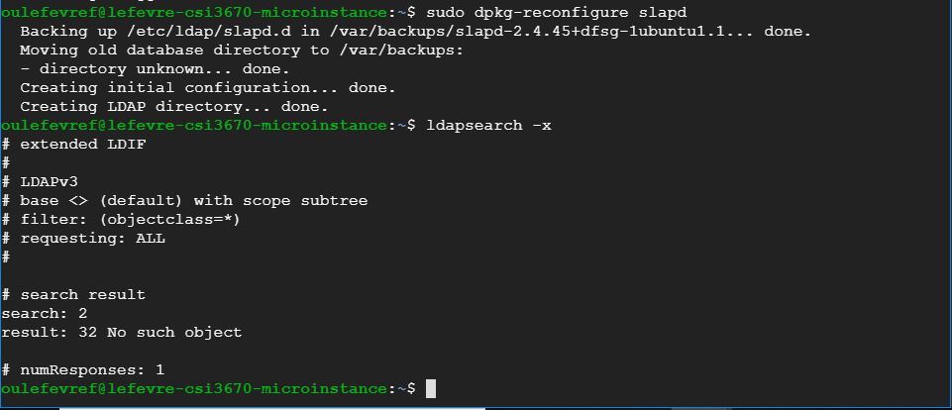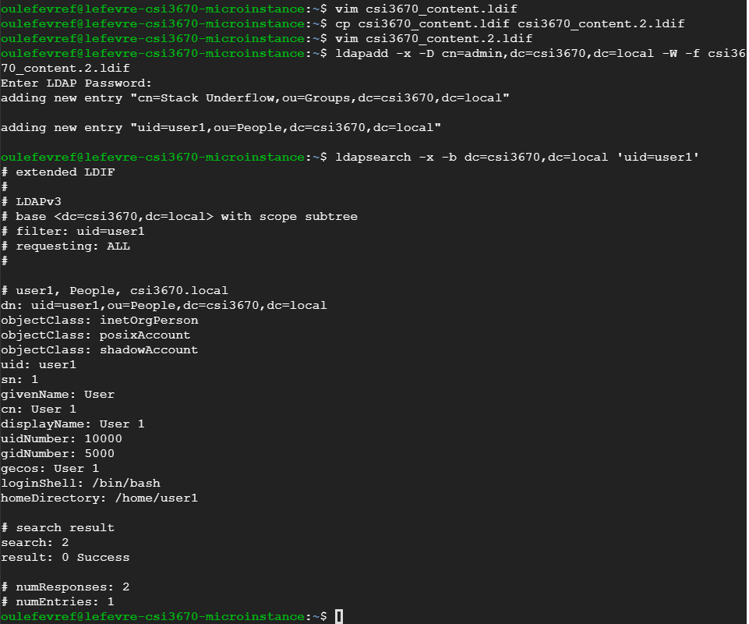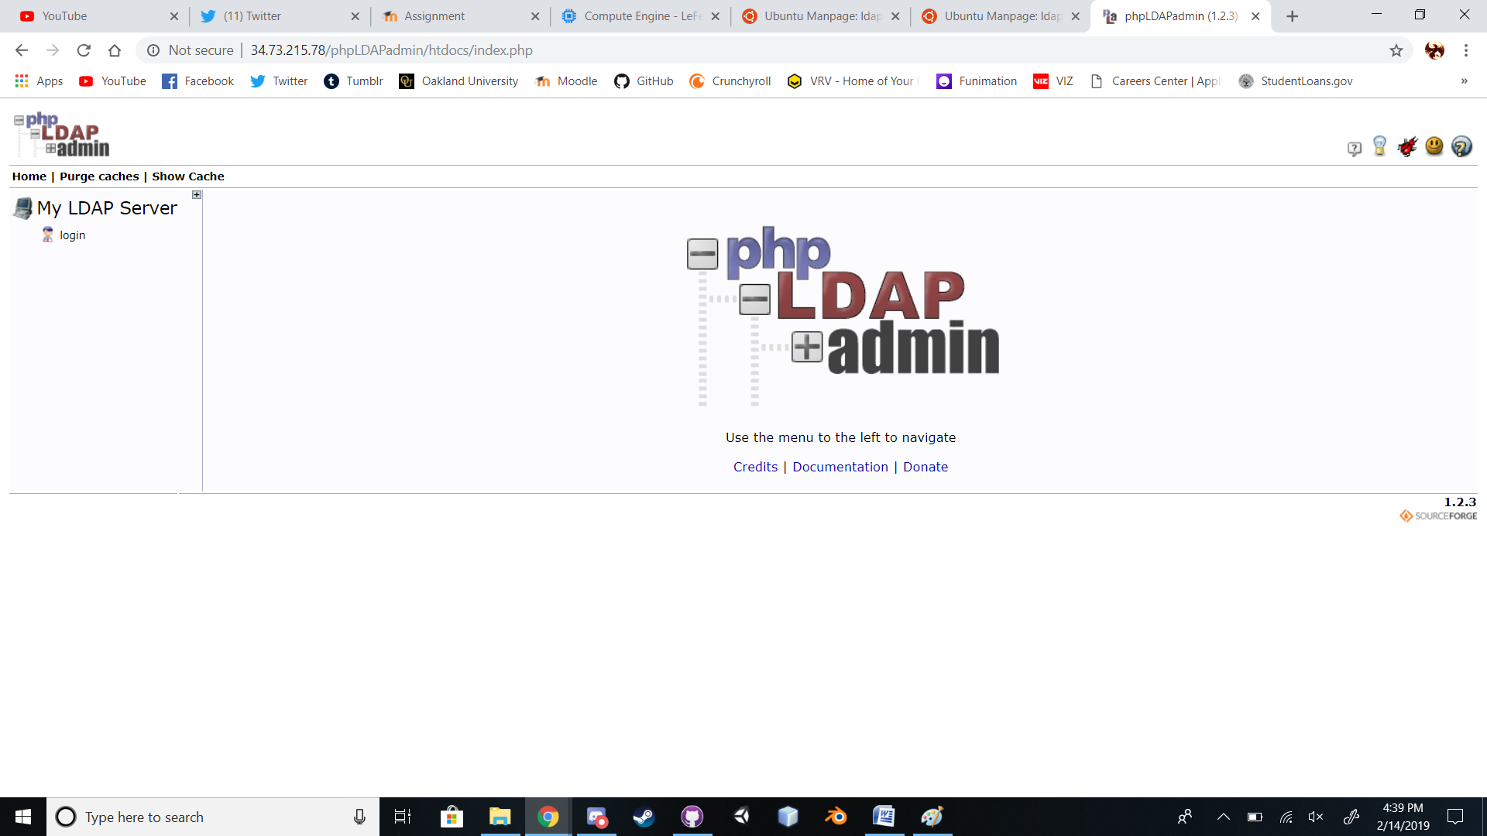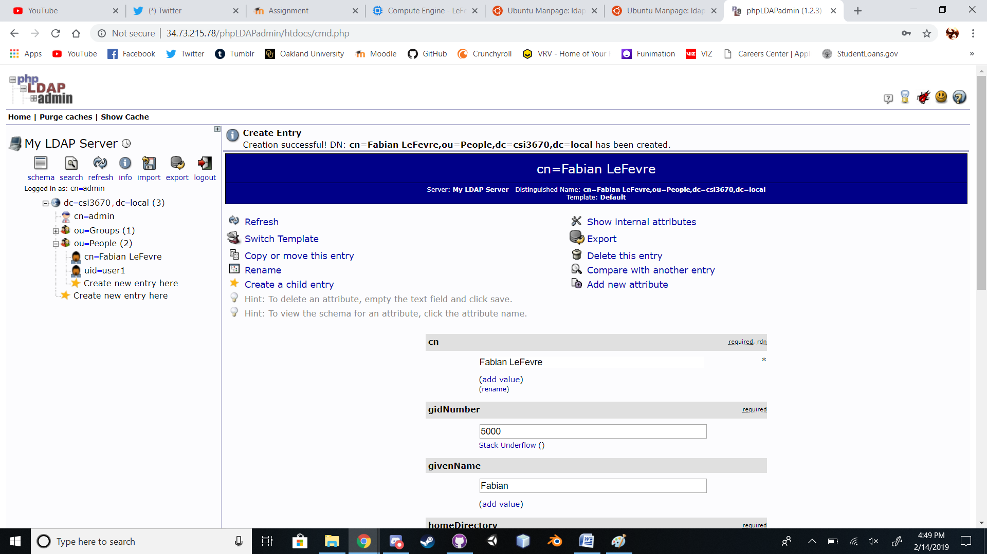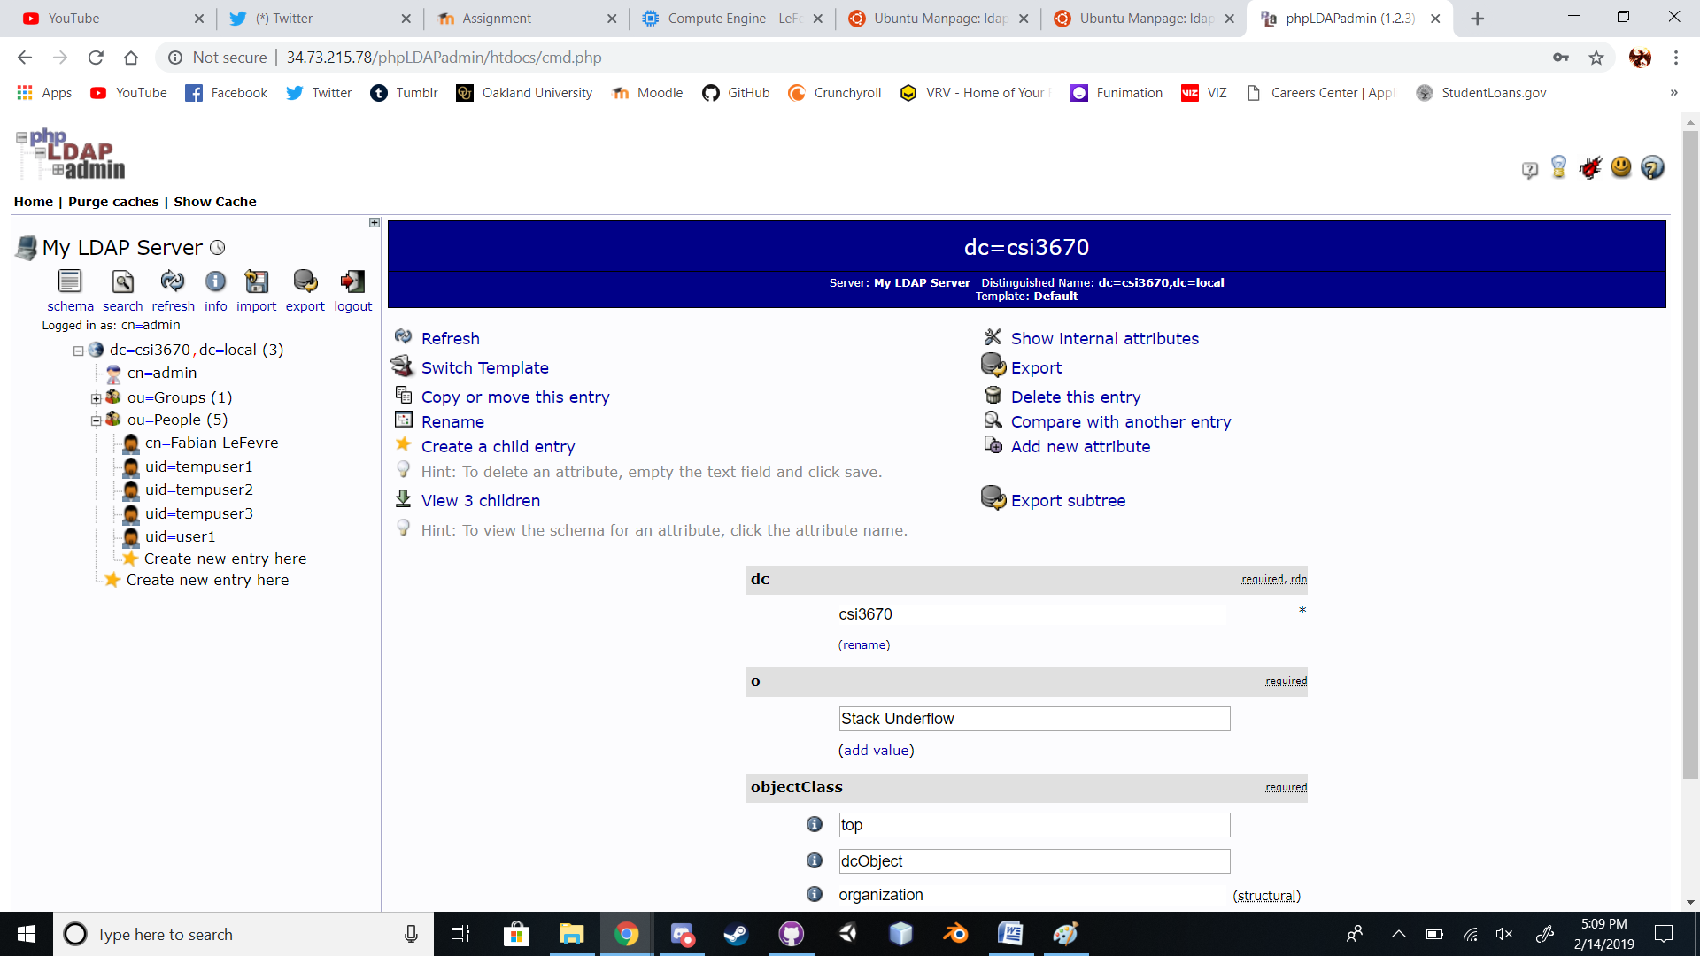

**2) Bash fun with LDAP!**

Create a bash script. Call it sample_user_add.sh

#!/bin/bash

# Comment block similar to the script from Part 1

users=( "tempuser1" "tempuser2" "tempuser3" )

userpw="temp12345"

ldif_file="/tmp/bulk_user.ldif"

dn="cn=admin,dc=csi3670,dc=local"

adminpw="temp12345"

i=0

for user in "${users[@]}"; do

touch $ldif_file

uid=$(( $i + 1000 ))

gid=$(( $i + 1000 ))

echo $uid $gid

echo "Adding $user to LDAP directory with UID [$uid] and GID [$gid]"

echo "dn: uid=$user,ou=People,dc=csi3670,dc=local" >> $ldif_file

echo "objectClass: inetOrgPerson" >> $ldif_file

echo "objectClass: posixAccount" >> $ldif_file

echo "objectClass: shadowAccount" >> $ldif_file

echo "uid: $user" >> $ldif_file

echo "sn: 1" >> $ldif_file

echo "givenName: User" >> $ldif_file

echo "cn: User $i" >> $ldif_file

echo "displayName: User $i" >> $ldif_file

echo "uidNumber: $uid" >> $ldif_file

echo "gidNumber: $gid" >> $ldif_file

echo "userPassword: $userpw" >> $ldif_file

echo "gecos: User $i" >> $ldif_file

echo "loginShell: /bin/bash" >> $ldif_file

echo "homeDirectory: /home/$user" >> $ldif_file

cat $ldif_file

# Add user

ldapadd -x -D $dn -w AD19ad19 -a -f $ldif_file

# Clean up

rm $ldif_file

i=$(( $i + 1 ))

done

Run it with bash (don’t run it with sh):

$ sudo bash sample_user_add.sh

**Take a screenshot or copy/paste the results here:**

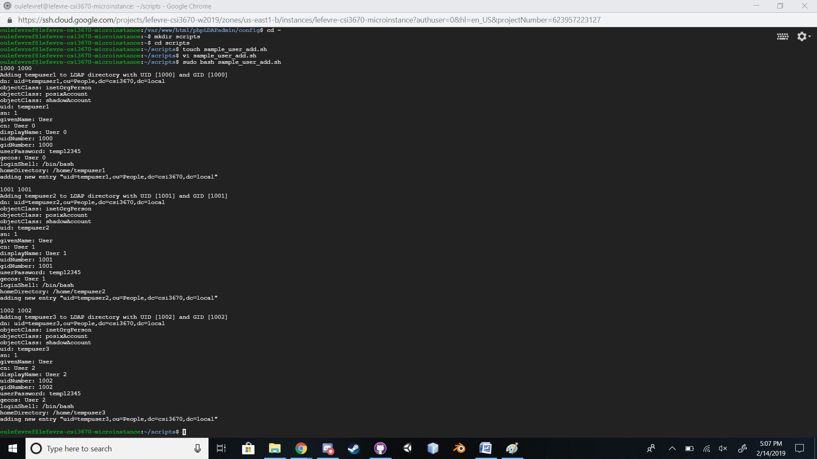

1. [From lab] Note that the user id and group ids are quite high. Why would this be the case?

**uidNumber: 10000**

**gidNumber: 5000**

1. [From lab] Run the following command. In Q3, describe what it does.

**$ ldapsearch -x -b dc=csi3670,dc=local subschemaSubentry**

**(This is correct)**

**Goes through to locate and describe the way the current domain tree is currently configured from passed parameters.**

1. What is LDAP and how does it compare to Active Directory?
2. What’s the difference between a DC and an OU in LDAP? What is their purpose?
3. What is a Distinguished Name?
4. Assume we are running an LDAP server for the class. What changes would need to be made to each *client machine*in order for them to authenticate with the LDAP server over a local login? You don’t need to provide exact details, but describe the technologies needed. This will require Googling, FYI.
5. Modify the script above to create a new user from the command line. Call it user_add.sh. It should accept a single user and password combination as follows (so, no need to loop anymore):

$ sudo bash user_add.sh username password

Run this and demonstrate that the user has been successfully added (either via phpLDAPadmin or anldapsearch query).

* 1. *For extra credit, make your arguments intelligent and read any number of user/password combinations.*

1. Zip up this report, your script(s) and any other materialsand submit to Moodle